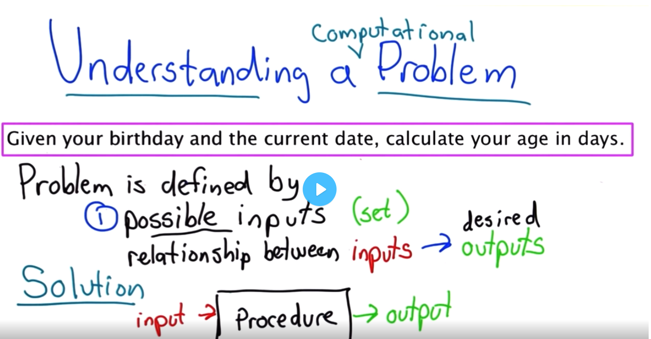

Input, output

1. Don’t panic
2. What are the inputs
3. What are the outputs
4. Solve the problem

Next:  
Workout some examples, **relationship** between input,output, testcases.

How to solve the problem as a human. Then move to code. **On paper**.

Write algoritm. Pseudocode.

Dates, df, are all the inputs are valid?1st data 2nd Second date must not be older than 1: invalid input

How input are encoded? (yyyy,mm,dd)

Output return a number because we can do things with return value rather printing it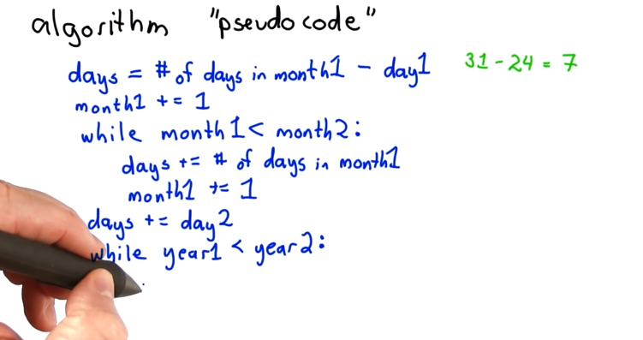

22 Continue